**FeelMoti changes**

1. Remove this. Because all the posts should be able to be on the right-hand side like on Instagram. We don’t need all the functionalities like price tag, and lock. All we need is just the post and photos and videos. The Document tab doesn’t need to be zip file but it could be excel, word, pdf, etc. this whole area should not be on the home page. There should be a pop-up for creating the post like Instagram.

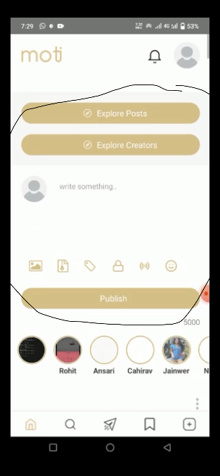

1. For the highlighted bubble will be on-demand content with both images and documents. This is service then we can write services. Basically, this area will have different items to sell for services. This can be a pre-recorded video or excel spreadsheet, or service. Users can write or upload the description of the service.



1. These services should be purchasable by the people that are subscribers or non-subscribers
2. Purchase will be done by in-app purchase. Everything should be an in-app purchase besides the sponsor button that should we have through stripe.
3. Profile picture is smaller compared to Instagram.
4. The post should continuously flow from one post to another. The faded yellow line should be removed.
5. Share icon is needed if the three dots are given. It would be better if it is just the three dots and not the share icon next to the comment.
6. The post and story design should be like Instagram.